DATE: 2025-11-09

REVISION: - A

TO: Geoffrey Butler, AE460 Instructor

FROM:

ALEBORNE

IAN PLANT

MAX O’NEILL
SUBJECT: Aircraft Layout and Mass Properties for the AIAA Strike Fighter

OBJECTIVE
The goal of this task is to complete an initial aircraft layout and perform a detailed weight estimate and mass balance analysis. These steps are essential for understanding the aircraft’s configuration, verifying feasibility, and ensuring proper stability and control. TM-8 will document the finalized layout along with the detailed weight and CG calculations.

Mass Properties
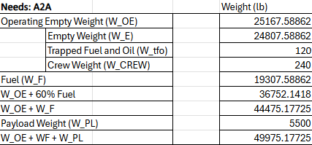
4.1 Weight Estimates

Figure 1: A2A Config.

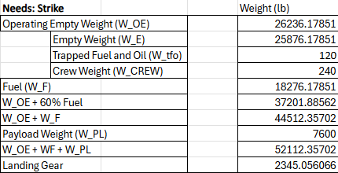

Figure 2: Strike Config.
The weight estimates listed above are for 2 different scenarios that require two different fuel capacities and payload types. This is due to mission criteria changing but regardless of the gross takeoff weight is relatively similar based on mission requirements.
4.2: Mass Properties
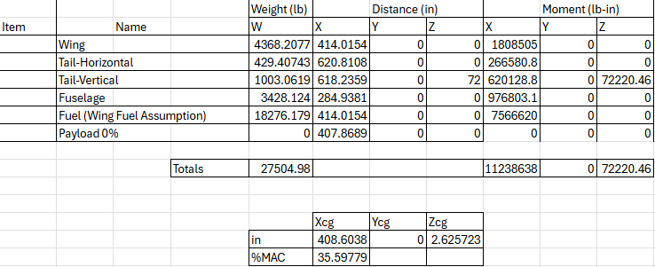
Figure 3: Clean Config.
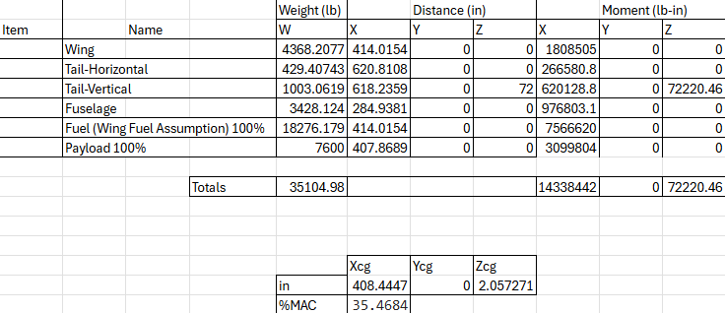
Figure 4: Full Config.
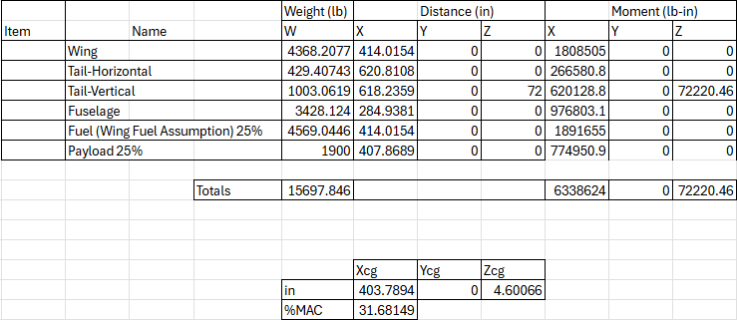

Figure 5: Worst Case Config.
Above are 3 mass properties tables which represent different configurations based on possible scenarios the designed strike fighter will have to overcome during missions. Each scenario has different payload expenditures and fuel reserves showcasing how the CG changes longitudinally based on the fuel and payload used on the mission. These tables were calculated based on the gross take off weight of the strike mission specifically.

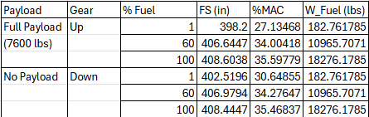
4.3: Longitudinal CG Movement
Figure 6: CG Movement based on different configs.
Similarly, the shift in CG longitudinally can be mapped based on landing gear position, payload weight, and fuel weight. However, due to the fact that the different fuel % and payload vary in this model, different configurations were not necessary. What can be seen above is a slight change in the longitudinal position of the CG due to fuel expenditure and payload, but what should be notes is that the FS location of the CG hardly changes at all due to the fact that when the gear is extended versus retracted, the location on the FS line remains relatively unchanged.

